Social Implications: Cyber crime
si_cyber_crime.php — Social Implications

Malware and Cyber Crime

Hackers, Crackers and script kiddies - they're out to get you!
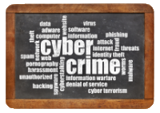
The online, electronic, cyber world is not without its dangers. In fact, the creation of this world has led to the creation of a whole range of new and hard to detect / hard to fight set of dangers, crimes and criminals that we have to deal with every day.
This section is an introduction to some of the concepts and dangers of Cyber Crime.
Hackers, Crackers and Script Kiddies
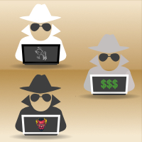
People generally use the term Hacker to describe a computer criminal.
The term actually is meant to describe anyone with mad computer skilz - anyone that loves to mess around with hardware and / or software and take computing as far as it can go.
If that means breaking into systems to see how they work, then that is just how the cookie crumbles…
They do what they do to figure out how things work, not to cause harm.
In short, to anyone in the IT world 'hacker' is not a word that is meant to be used to describe a criminal.
The word for that is Cracker. A cracker is a person who uses their mad computer skilz to do bad things - like spread malware, steal money, data or identities, hold systems to ransom, etc.

Different Hats of Hackerdom
If you are going to stick with the word hacker then you need to know about the qualifying adjectives used with the word.
These are:
- White Hat Hacker:
These are the good guys. They find bugs and exploits so that they can be fixed. They offer their services as 'penetration testers' so that they can break into your network and find its weaknesses before the bad guys do - and help you to fix the weaknesses and make your system more secure.
- Black Hat Hacker:
These are the bad guys - they steal and destroy.
- Grey Hat Hacker:
These guys go where the money is - they sell their skills to the highest bidder.
If you ever use the term hacker you should use these qualifiers to show which type of hacker you are talking about.

Script Kiddies
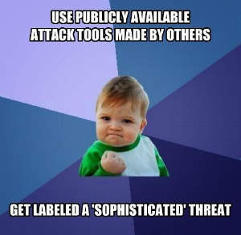
Script Kiddie Meme from Know Your Meme
Script Kiddie is a nasty, offensive, derogatory term. Calling someone a 'script kiddie' is a third degree burn.
'Script Kiddie' is used to describe people who cannot create their own hacks. Instead they buy / steal / download hacking code that is available on hacking sites (these are usually only accessible on the Dark Web using the Tor browser) - and then modify this code to do what they need.
They are playing with 'scripts' (code) that they have not written and may not understand. They are 'kiddies' because they are unable to create code themselves.
Variations include Kiddies, Skiddies & Script Kitties.
Return to the top of this panel
Malware
Malware is a combination of the words Malicious and Software - it is basically any software with bad intentions.
There are many types of Malware - and what makes it all confusing is that they often combine features and techniques - so saying that X is a worm and Y is a Trojan is often not quite true.
The main types of malware are described for you below. Please, if you are going to use one word for all the bad software out there, don't use 'virus' but rather stick to 'Malware' for the sake of accuracy!
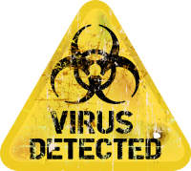

Virus:
Technically a virus is a bit of executable code that attaches itself to a program and spreads when that program gets copied to other computers and run.
When you run an infected program the virus is loaded into memory along with the program. When loaded in memory a virus will attach itself to all other program files it can find on the users storage.
The term is used by most people instead of the word 'malware' to talk about all badly intentioned software.
A virus has a payload which is the part of the virus that will do something besides copying the virus onto other programs. The payload can be as silly as displaying a stupid message or as vicious as deleting all the files on your hard drive.
Most viruses contain a unique 'signature'. The signature allows the virus to check if it has already attached itself to a file. Before infecting a file, the virus checks the file for its signature. It does this because some early viruses kept on re-infecting the same files over and over again, making the file grow in size and giving the virus's presence away!
These signatures (for viruses and all other malware) are what is used by Anti-malware software to detect a virus on your computer - looking for signatures is part of what the anti-malware software does when it scans your computer.
Though one of the first types of malware, viruses are far less common today with worms and trojans topping the list of the most common types of malware.
Scanning an executable file that you download or get from someone else with an up to date version of an Anti-Malware program is the best way to prevent problems with viruses.
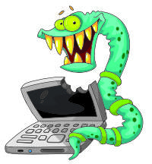

Worm:
A program that can copy itself from computer to computer over a network.
The scary thing about a worm is that you don't have to download anything or click on any attachment or run any software to get infected.
A worm runs on an infected computer and uses that computer's connection to scan the network / internet for other computers. If it detects a computer the worm tries to upload a copy of itself to the new computer. It uses vulnerabilities in the computer's OS and networking software to spread itself this way.
One of the best ways to prevent being infected by a worm is to have a strict firewall that alerts you any time any software / computer on the network is trying to connect to your computer. If you do not know or trust the source you don't allow the connection. If the connection is blocked, then the worm cannot infect your computer.
Worms are a common technique for turning your computer into a 'zombie' or a 'bot' - allowing it to be controlled remotely by the malware author and letting it be used for tasks such as sending spam, launching DDOS attacks, cracking passwords, etc.
Because Worms rely on vulnerabilities in the OS another good way to prevent infections is to keep your OS up to date - install patches / fixes / updates as soon as they become available! Anti-Malware software will detect a Worm and may be able to remove it, but is already too late as you have been infected!
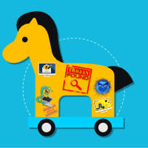

Trojan:
A program that pretends to do something useful (e.g. block advertising on your browser) but actually does something bad (spies on you and sends your data off to someone else).
Trojans do not infect files or spread themselves like worms. Instead they rely on tricking you or fooling you into activating them. You download and run the file. You open the email attachment. You visit the web site. You are the way that trojans gain access to your computer.
The name Trojan comes from the Greek legend of the siege of Troy. Troy and Greece are at war. The Greek army has laid siege to the city for months but the Trojans keep them out. The Greeks pretend to give up and sail away. They leave behind a large wooden statue in the shape of a horse. The Trojans drag the statue into the city. At night Greek soldiers climb out of their hiding place in the belly of the statue, open the city gates for the army (which snuck back to the city) and attack the Trojans - killing almost everyone and destroying the city.
Examples of trojans include software cracks (sure they may crack the software so that you can pirate it, but they often also do something else such as install a backdoor or a worm).
Trojans can be email attachments with false extensions or that contain macros; software downloaded over the internet (especially when the download is not from the official site of the software creator); screensavers or other utilities from no recognised software company; web apps that say they do one thing but actually download and install other malware onto your computer.
A trojan can even be that flash drive, CD / DVD or external hard drive that you find somewhere. You are curious and so connect it up to your computer…. And most times that is all that is needed - a program loads itself as soon as the storage is connected and you are infected.
Trojans are the most common form of infection today. They are a popular way of infecting computers with other types of malware - and for turning your computer into a 'bot' or 'zombie'.
Trojans can be detected and removed by Anti-Malware Software. But this is often too late, because you have usually already activated them.
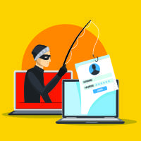

Phishing:
Phishing is not any kind of software or program.
Phishing is a type of social engineering (a polite way of saying a con or a scam).
The Phisher sends you an email pretending to be from a bank or service provider. The email says your details are our of date and you are likely to lose access to your account.
The e-mail contains a link to take you to a web site to fix the problem.
This is the critical bit: DON"T CLICK THAT LINK!
The linked web site is fake (but may look like the real thing). When you enter your details on this site they are stolen by the phisher.
Just like a real fish, you took the phisherman's bait and got caught!
Phishing is one of the most common ways of stealing identities, breaking into computers, stealing passwords and stealing money.
Phishing is often detected by a good Spam filter.
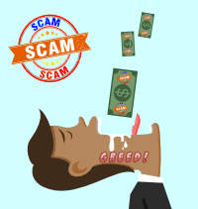

Scams:
These are commonly called Nigerian 419 scams or Advance Fee scams.
The basic idea is that someone needs your help to get their money out of their country - for which you will be paid a generous fee. Either that or you have won a lottery or have an inheritance from a long lost relative or someone wants you to administer a charity with lots of money or…. anything where you stand to gain a lot of money.
The problem is, you need to pay a fee to make it possible for you to get the money.
The scammer is just after the fee - you pay and they will come up with reasons you need to pay more. When you eventually stop paying the scammer vanishes along with your money and the non-existent reward you were promised.
These types of scams rely on greed to work. It is also argued that they contain poor language and grammar as a kind of 'pre-selection' process. If you don't see the language errors or don't pay attention to them - and reply to the scammer then you have 'pre-selected' yourself as a victim and are less likely to lead to trouble for the scammer. Smart people pick up on the language and stay away!
These types of scams are often detected and deleted by a good Spam filter.
Remember: there is no such thing as a free lunch!
If it looks too good to be true, it probably is!
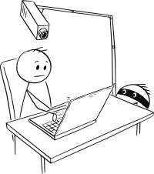

Spyware and Adware:
These are both programs that monitor what you do with your computer.
Spyware takes the data and sells it to someone else.
Adware takes the data and uses it to sell advertisements that are displayed on your computer.
Spyware can also include software such as Keyloggers that record everything you type on your computer (and often also screenshots of where your mouse is when you click). This type of spyware is used to steal data such as login names and passwords.
You even get spyware that turns on your webcam / microphone so that you can be watched / listened to remotely.
Spyware is most often added to your computer using a worm or a trojan.
You often install adware yourself (free software that displays advertising) or use advertising supported services such as Facebook or Google.
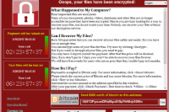

Ransomware:
This is software that encrypts your data and will not decrypt it until you pay a ransom.
Ransomware is usually installed through a worm or a trojan. As soon as it is installed it starts encrypting your data.>/p>
When the encryption process is finished it displays a message telling you that your data is locked and gives instructions on how you have to pay to 'free' your data. There is usually a short time limit and a countdown clock displayed as well.
Don't pay the ransom - most of the time when people pay the malware authors do not decrypt their data!
The only solution to ransomware is to have a good, up to date backup that you can use to restore your system.
NB: DO NOT leave your backup drive connected to your computer all the time. If this drive is connected when you get infected with ransomware then it will also be encrypted and you will no longer have a useable backup!
Return to the top of this panel
Spam
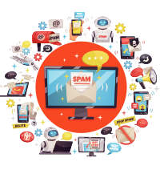
Spam is unasked for email - usually advertising something like viagra, penis enlargement, porn or similar. It can also be advertising for more mainstream consumer products. It is just mail that you have not asked for and that it is sent out to millions of people globally.
Spam is a problem because it wastes your time, makes people fear and distrust email - and because of the sheer amount of bandwidth it takes up (all those messages have to be sent and received).
Your ISP or email provider usually has a spam filter in place - so often you don't even get to see all the spam that might land in your inbox!
Installing your own spam filter might help reduce the spam you see even further.
Spam filters are useful as they often block phishing emails and scams / hoaxes as well.

Why does spam continue even if most of it gets blocked?
Well, the cost of sending out spam is usually close to zero. Spammers usually don't send out the messages themselves but get a 'botnet' of zombie computers (computers infected by a worm or trojan that have a backdoor that allows them to be controlled remotely) to send out the spam for them.
If they send out 1000 million spam messages and 0,1% of those messages get through that leaves 1000 000 messages that did get through.
If only 0,1% of those messages get a response that is 1000 sales.
If each of those sales is worth $10 then they have made $10 000 with virtually no effort or cost to themselves.
Spam is a volume game - and will continue to be a problem as long as even the smallest portion of the population keeps on responding to it!
Return to the top of this panel
Pharming, Click Jacking & Spoofing

Pharming
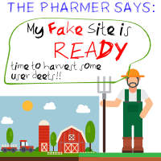
Pharming is a browser / web based attack aimed at stealing the user's login information.
Pharming is actually a type of DNS poisoning attack. To know what Pharming is you need to understand how it works.
NB: No Anti-Malware software can keep you safe from farming. This responsibility lies with the DNS system, ISPs and the target web site (in the example below 'mybank.co.za') itself.
A possible way to identify if a site has been 'pharmed' is if a SSL certificate error gets displayed when you visit the site.
Follow the step-by-step guide to Pharming below.
Step By Step Guide to Pharming
An explanation of how Pharming actually works.
All Done!
Your details have been harvested and the pharmer has got a successful, working Pharm...
Create a fake web site
The 'Pharmer' creates a fake web site that looks like the real site.
In this case, let us imagine that the pharmer is duplicating 'mybank.co.za'.
The fake site will look as much like the real 'mybank.co.za' site as possible.
Remember, the pharmer wants your login details (name and password) and wants you to believe that you are on the real site, so this copy will be as close to the real thing as possible.
Corrupt DNS
Pharming is an attack that targets many users at once.
Pharming attacks will try to change (poison) the DNS information in routers or DNS servers. The idea is that if you get the DNS server to send out the IP address to your fake site instead of the IP address to the real site then anyone trying to go the real site becomes part of your pharm.
Sometimes pharming can involve a direct attack on your computer instead of a DNS server. You will be part of a widespread attack meant to compromise DNS information on the computers of many users. The way it works is as follows:
Your computer keeps a local cache of the IP addresses of the sites you visit often - in Windows this is stored in a file called 'Hosts.txt'.
The pharmer will usually try to corrupt your local DNS records on your computer - i.e. they will change the IP address for a URL.
This will usually be done using a Trojan. You run the trojan and it changes the DNS information stored on your computer (e.g. it changes 'mybank.co.za' IP address from the address of the real site to the IP address of the fake site the pharmer has created.
Sit back and wait…
The next time you try to go to 'mybank.co.za' your computer will get the IP address either from your local cache or from a DNS server.
The pharmer has changed things so that whether you type in 'mybank.co.za' or click a link or use a bookmark your computer will get the IP address of the fake site.
The fake site looks real, so you type in your details. The site seems to let you log in but then gives a 'technical error' and asks you to try again later'. This is to hide the fact that the site is fake.
The pharmer now has your details and can log into your account on the real site and do whatever it is they want to do (usually steal money).

Clickjacking
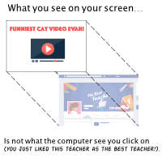
When you hijack an aeroplane the aim is usually to get the aeroplane to go to a new destination.
That's the idea behind clickjacking.
The cyber criminal captures the user's clicks and sends them off to a different destination from what the user intended.
A clickjacking attack is a type of trojan attack.
Clickjacking takes place inside a web browser. No Anti-malware software can protect you from clickjacking. The creator of the web site has to make sure that they protect the site by stopping it from being displayed in a a frame on another, different web site.
The aim of clickjacking is to trick users into:
- Following someone on Social Media (Twitter / Facebook)
- Liking something on Facebook / retweeting something on Twitter
- Downloading / installing malware
- Sharing something on social media
- Clicking on Google adverts
and so on…
Once again, the only real way to understand clickjacking is by following a step-by-step tutorial on how it works.
Step By Step Guide to ClickJacking
An explanation of how ClickJacking actually works.
All Done!
The clickjacker is happily selling people extra likes and follows - all at your expense.
Set up a web site
The clickjacker creates a web page that shows the user something they want to click on.
They then make this visible page transparent to the computer / mouse (you'll see what is meant by that in a moment).
They then place another, real site over or under what the user sees. This site is invisible to the user (but not to the computer).
Capture the clicks
Now when the user sees something they like and want to click on (e.g. the 'play' button on a video or the 'download' link to a free file) that click is captured and used by the second, invisible part of the page to do something like follow someone on Twitter, Like something on Facebook, etc.
But…. Why?
Well, Social Media is kinda like a popularity contest.
What matters is how many followers you have, how many likes / shares you have, etc.
If you can't get these the honest way, then often people pay to gain users, likes, shares, etc.
The people they pay can't afford to have all the follows / likes / etc come from the same user/ IP address / etc. because that is easily detectable as fake.
One solution they use is 'bots' - fake accounts controlled by zombie computers that do as instructed.
Clickjacking is another solution to the problem…

Spoofing
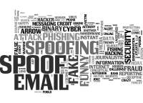
Spoofing applies to email.
Spoofing is changing information in an email header to make it look like the email comes from a different source.
If you are a scammer / phisher / cyber criminal you might want to send out emails that look like they really come from a trusted source (e.g. your bank).
Each email that you send and receive has a lot of informations stored in its 'header'. You never really see the whole header, only the sender, received and CC /BCC blocks that your email program shows to you.
Well, spoofing is simply when the bad guys change this information to make the email look more trustworthy.
Return to the top of this panel

Video Links - Cybercrime and Malware
We have selected and curated a set of videos on YouTube related to your course.
These videos are not created or owned by us.
They may display advertising and in some cases may contain limited amounts of swearing.

Notes for this Module
What to look out for and do in this module...
The FAQs are not questions that are likely to appear in exam papers - they are real questions that most people ask about the content.

FAQs for this module
Questions on Malwars & Cyber Crime - and their answers...

Network Types FAQ
View the questions or type in the term you are looking for below…
No results were found

Malware, Virus, Worm, Trojan, Spyware… why is it all so confusing?
There are many words and terms because people are trying to be specific in describing what the bad guys are doing.
This helps to make it easier to understand and fight against the bad guys.
Unfortunately, the bad guys don't give up and keep on coming up with new attacks - or creative ways to combine old attack methods together to create new attacks.

How bad is adware really?
Its not dangerous in the same way as other types of attacks - it is just irritating (and creepy when the same advert keeps showing up on all the web pages you visit).
You really have to decide how much you're privacy matters to you.

Why the fuss about privacy? Surely it doesn't matter if I have nothing to hide?
You are a novelist. You are researching stuff on the internet about a character that has a rare disease. Next month your medical aid fees go up…
Your activity was tracked, the company found out, thought you might be a risk and so increased your premiums.
That is one example of how privacy can matter.
There are many other examples.
Think about it!

Is piracy so bad?
Piracy shows a lack of respect for and a devaluation of other people's work.
It is something that you should not do.

What are the most popular and common attacks?
Phishing.
Trojans.
Worms.

What is a Zero Day?
A Zero Day is a bug or vulnerability that is unknown and unpatched.
A Zero Day can be used to break into a system.
Bad guys pay for Zero Day exploits because it means their hacks have a good chance of success.
Governments buy Zero Day exploits as a kind of Cyber Warfare armoury.
Companies offer good guys 'bug bounties' to find Zero Day exploits and tell them about it so that they can fix them.

What does a White Hat Hacker do?
A white Hat tries to find vulnerabilities and weaknesses so that they can be fixed.

